* 1. **Project description**

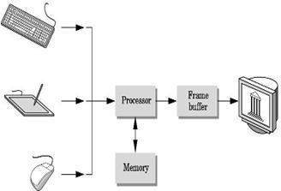In India, migration of people from rural to urban is increased day by day. About 70% of population is living in cities, because requirements of peoples are not fulfilled in villages. There are 600000 villages out of them 125000 are backward. So it necessary to design and development of as a smart village with urbanization and modernization peoples migrate from one place to another for different facilities such as education, employment, affinity of people towards the city. Village is main criteria for development of nation, so develop the village in such a way that which is self dependent in providing the services, employment & well connected to the rest of world & new technology that is SMART VILLAGE. The smart village corrects providing facilities for sustainable family relationships without disturbing the lifestyle of different generation. Initially the concept of development of village is of Mahatma Gandhi that is “Swaraj & Suraj village” but now it’s time to change, newly term as smart village. Our vision of smart village is that modern energy access can act as catalyst of development in education, health, clean water, sanitation, and environmental sustainability. Development of nation at any phase is linked with technology and when it happens there is advancement in science and innovation. Now-a-days our government also gives strong focus on smart village. So our project is also a small step towards to make India as developed nation to the progress of village and smarten the rural development using ICT solution to achieve selfsustainability.

Fig.1.1 Computer Graphics System

Computer graphics started with the display of data on hardcopy plotters and cathode ray tube (CRT) screens soon after the introduction of computers themselves. It has grown to include the creation, storage and manipulation of models and manipulation of models and images of objects. These models come from a diverse and expanding set of fields, and include physical, mathematical, engineering, architectural, and even conceptual structures, natural phenomena, and so on. Computer graphics today is largely interactive.